

booking one way cab hackathon

Functional Requirements Document



Booking one way cab –Functional Requirements Document

Cognizant

**Booking one way cab**

**Functional Requirements Specification**

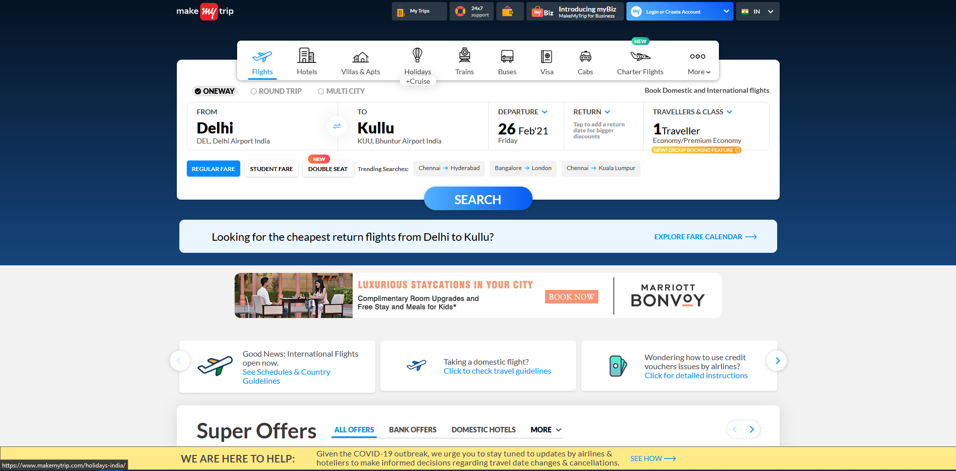

Table of Contents

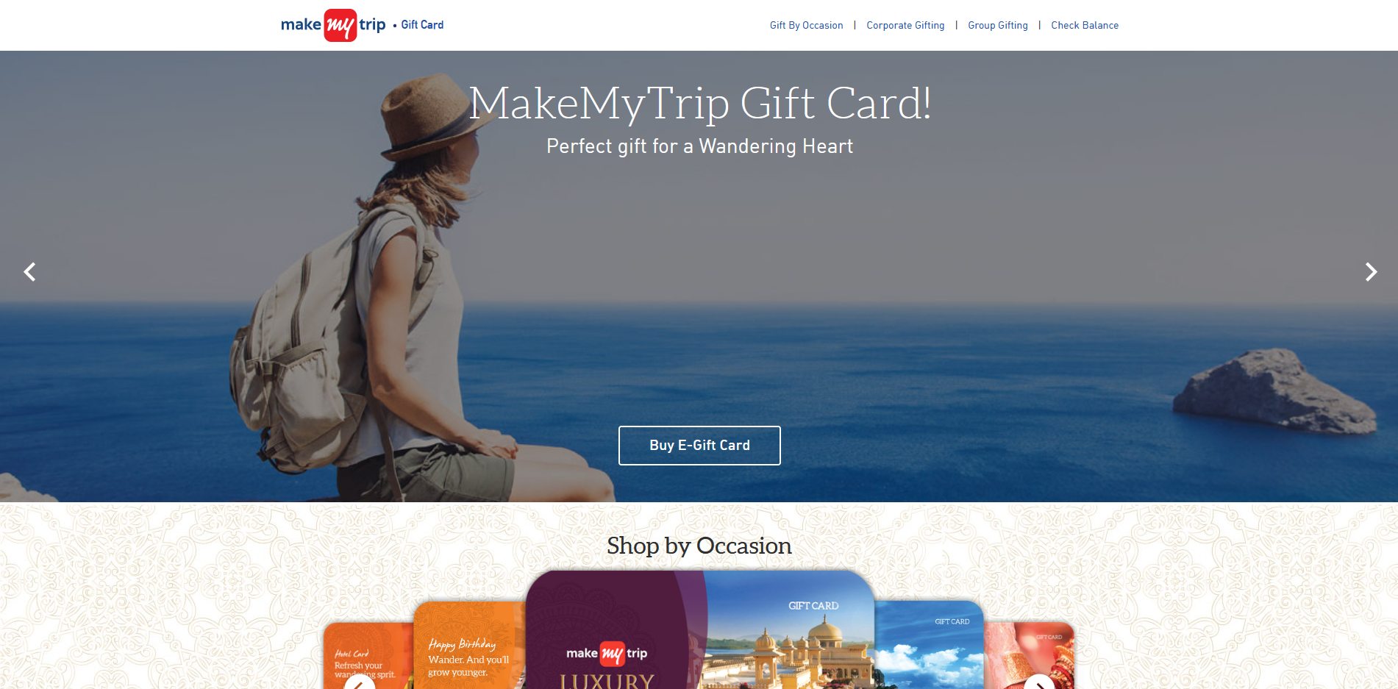

1. **BOOKING A CAB IN MAKE MY TRIP WEBSITE-------------------------03**
   1. OVERVIEW-----------------------------------------------------------------------------03
   2. USER SETUP---------------------------------------------------------------------------03
   3. BOOKING A CAB----------------------------------------------------------------------03
   4. Selecting the Type of Transport – cars------------------------------------------04
   5. Selecting the Type of ride----------------------------------------------------------04
   6. Enter ride details---------------------------------------------------------------------04
   7. Search Functionality-----------------------------------------------------------------05
   8. Selecting the Car Type---------------------------------------------------------------05
   9. Booking the Cab----------------------------------------------------------------------05
   10. Proceed to Payment--------------------------------------------------------------06
   11. READ BEFORE YOU BOOK-------------------------------------------------------06
2. **Hotel booking page**-----------------------------------------------------------09
   1. Overview-----------------------------------------------------------------------09
   2. Selecting a City---------------------------------------------------------------09
   3. Selecting Check-in and Check-Out Date-------------------------------09
   4. Selecting Room and Guests-----------------------------------------------10
3. **Buying E-Gift Cards**
   1. Overview-------------------------------------------------------------------------------13
   2. E-Gift Card Website-----------------------------------------------------------------13
   3. Types of Gift Card--------------------------------------------------------------------13
   4. Enter Gift Card Details--------------------------------------------------------------14
   5. Enter Sender and receiver details------------------------------------------------14
   6. Proceed to payment-----------------------------------------------------------------15
4. **FAQs**-----------------------------------------------------------------------------------------16
5. **Terms and Conditions**---------------------------------------------------------------17

**BOOKING A CAB IN MAKE MY TRIP WEBSITE**

**1.1 OVERVIEW**

To Book a One-way Cab, First of all we need to have a device like Mobile or Laptop or Desktop with a proper internet connection. The Make My Trip website or application should be available. Then the user should select the cabs options for booking a cab. Under that we need to select the OUTSTATION ONE-WAY for booking a one-way cab services. The user should fill the required details of from and to location for a trip. Then they have to select the Departure date, day and also the car type. Then the user will able to see the list of cars available. So they can select any of them by clicking on the book button and the payment should be made. Then the cab is booked successfully.

**1.2 USER SETUP**

User can able to

* Book the cabs
* Send Gift Cards
* Book the hotel

A User will consist of

* Name
* Contact Number
* Email Id

**1.3 BOOKING A CAB**

To Book a one-way cab, the Make my trip website or application should be available.

Here are the following sections for Booking a one-way cab:

* Selecting the Type of transport - cars
* Selecting the Type of ride
* Enter ride details
* Search Functionality
* Selecting the Car type
* Booking the Cab
* Proceed to Payment
* Read before you Book

**1.4 Selecting the Type of Transport - cars**

The user should select the type of transport. All the options are available in the homepage of the Make my trip Website. From the above options , the user should select the Cab option.

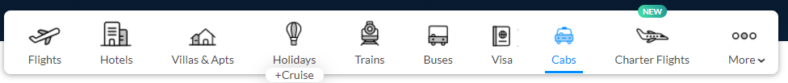

**1.5 Selecting the Type of ride**

Selecting the type of ride by the user from the options provided by the website. There are three options available for type of ride. The user should be able to book any one of them.



**1.6 Enter ride details**

In this section, the user should able to enter the details of the ride like from and to location, departure date and time etc.

* Enter the From location
* Enter the To location
* Enter the Departure Date
* Enter the Departure Day

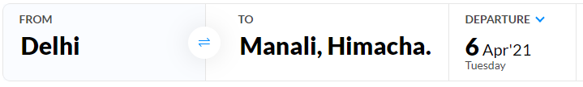

**1.7 Search Functionality**

In this section, the user will able to search for the cabs by clicking on the search button. Then the user able to see the list of cars available for the ride.



**1.8 Selecting the Car Type**

In this section, the user will be able to select the car type. There are three options available of car type like HATCHBACK, SEDAN and SUV. The user can select any one of them from the options available.

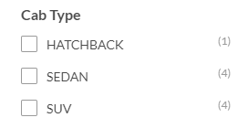

**1.9 Booking the Cab**

In this Section, the user will be able to book the cab based on the options available.

* The user should select the Car for the ride
* The user should click on the book button for booking the cab.

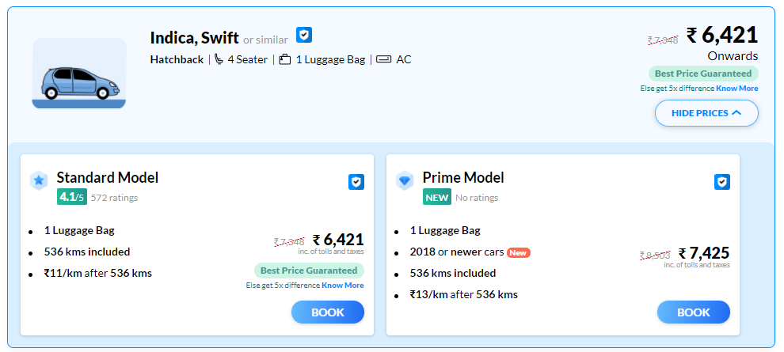

**1.10 Proceed to Payment**

In this section, the user will be able to proceed to payment page for payment of the cab selected in the previous module. Here, we can see the Driver and cab details 30 minutes prior to departure. The following sections for payment options are

* Enter the Trip details

1. Enter the Pick-up Address
2. Enter the Drop-off Address

* Enter the Name
* Enter the Email id
* Select the Gender
* Enter the Contact Number
* Enter the coupon code (if applicable)
* Click on Pay Now option

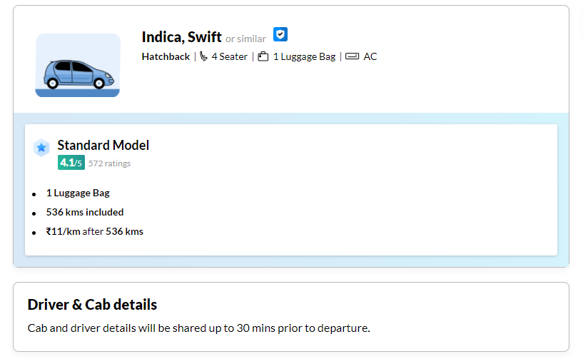

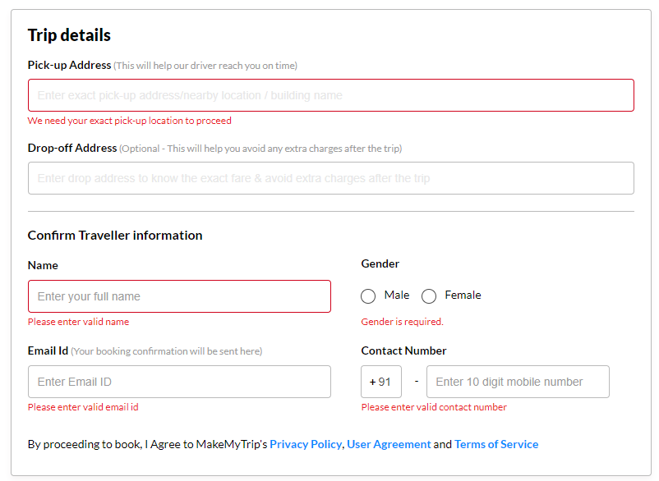

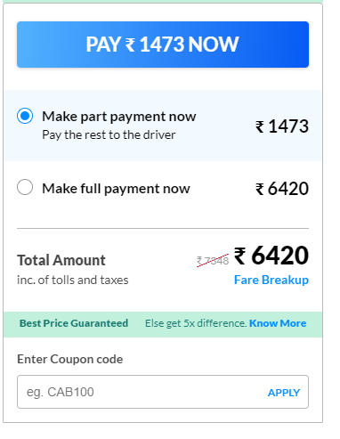

**1.11 READ BEFORE YOU BOOK**

This sections is about the Guidelines that the user should be known before they book the Cab. They are listed Below:

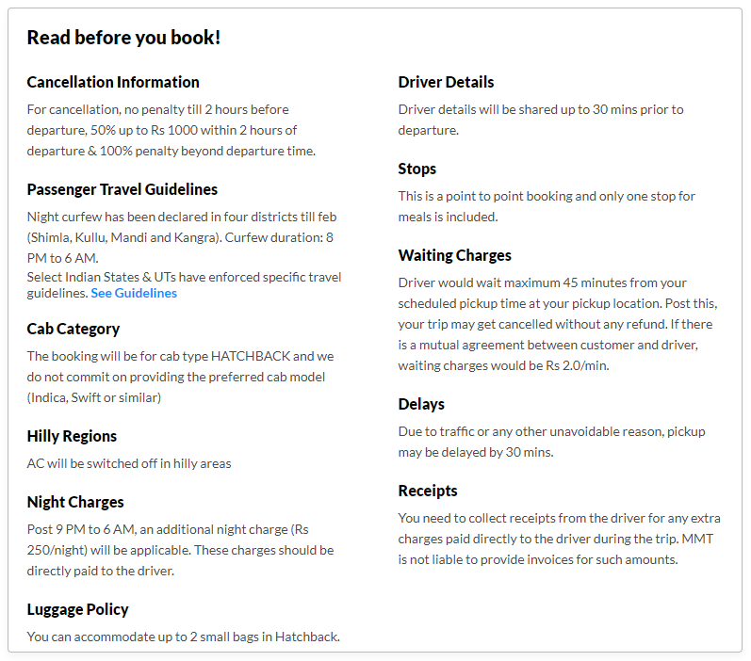

1. **Hotel booking page**

**2.1 Overview**

Booking of Domestic and International Hotels and Homestays can be done using this page. To book a Hotel user needs to enter the City name where they want to book a hotel, Check-in and Check-out dates, Number of rooms they want to book and the Number of Guests for whom user want to book a hotel for.

**2.2 Selecting a City:**

* By Clicking the ‘City’ Label Field, User will get the Drop-Down Box, by using it user can select the city and also user can enter the City Name in the Textbox as Shown below.

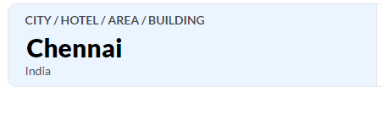 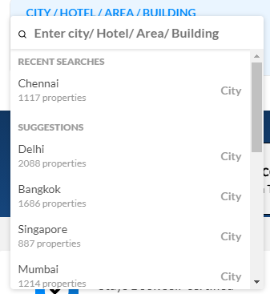

**2.3 Selecting Check-in and Check-Out Date:**

* By Clicking the Check-in Box, User will get Calendar Box, where they can select the date of Check in and also the date of Check-out after selecting Check-in Date.

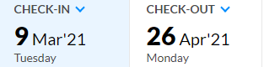

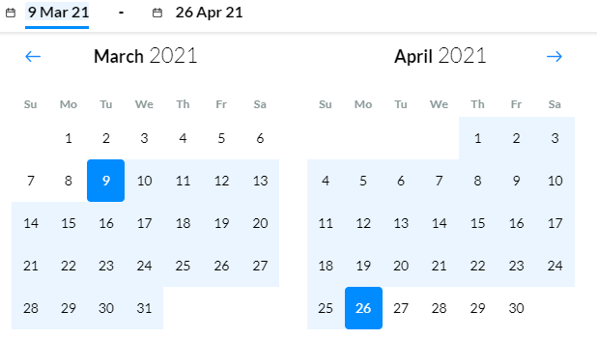

* Check-out date cannot be selected on the same date of Check-in
* If, the Check-out Date is selected as more than 30 days from the Check-in Date. Then, Display message will show as



**2.4 Selecting Room and Guests:**

* By Clicking the ‘Room and Guests’ Label field, user can select the Number of Adults and Number of Children (Below 12 years of age). The Maximum number of Guests can be selected as 12.

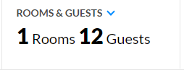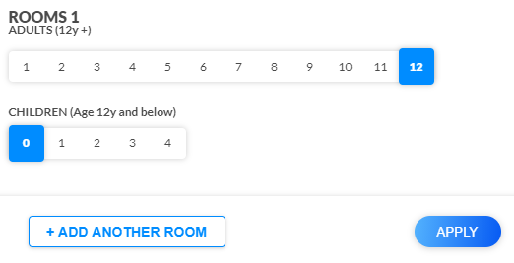

* By Selecting the Number of Children, from 1 to 4. User need to select the age from the drop-down box.

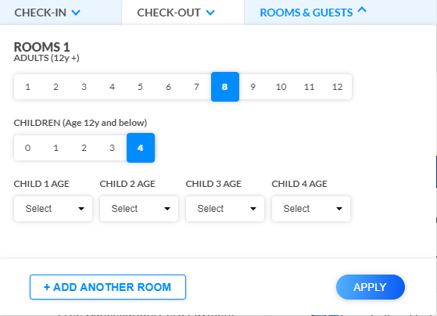 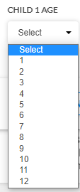

* If the user selects more than 12 guests, it will show as 
* User can add the Number of Rooms by clicking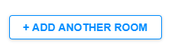
* User can add up to 10 rooms and not more than that.

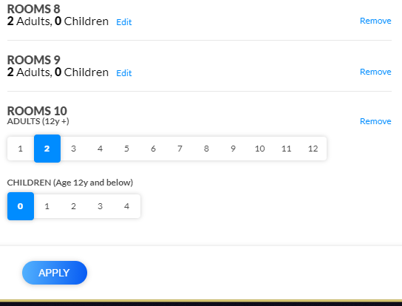

* Click Apply and Search Button, Hotels based on the requirement will be displayed.

1. **Buying E-Gift Cards**

**3.1 Overview**

Gift cards are used by the individuals and corporates, it can be either physical card or Electronic Card for getting a small discount or a free ride on make my trip website or in the android app. The denominations of the gift card may vary according to the customers wish minimum is Rs.10 and the maximum amount is Rs.50,000. The Gift Card will contain a Voucher number and a voucher pin and the denomination amount and a validity date.

To buy a gift card the user need to enter the details of the sender and the receiver in the Enter sender and receiver details section. The payment can be done using the Credit Card, Debit Card or Net banking. Once the checkout process is completed successfully the sender will get a purchase receipt on the email and the receiver will get the E-Gift Card on email or Physical card through courier.

**3.2 E-Gift Card Website**

The E-Gift card website can be found in the “makemytrip gift cards” website and in the E-Gift Card website there are **seven** sections.

* Types of gift card
* Select your theme
* Enter Gift Card Details
* Enter sender and receiver details
* Proceed to payment
* FAQs
* Terms and Conditions

**3.3 Types of Gift Card**

Selecting a Gift card type by the user to send it to the receiver. All the options available are festivals and Special occasions the card types are available throughout the year but can only.

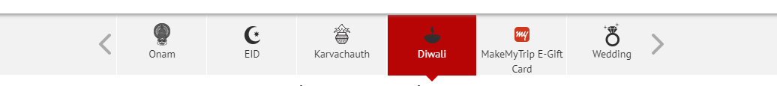

**Select Your Theme**

Selecting the theme by the user from the default themes provided by the website. There are only five themes for every type of Gift card and only one can be selected for one Gift Card.

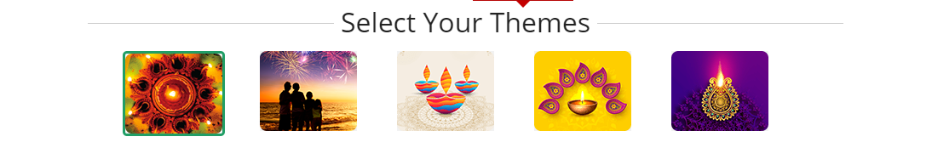

**3.4 Enter Gift Card Details**

This section has the denomination and the quantity of the gift card and the delivery date and a message from the sender to the receiver

* Enter the Denomination value for the Gift card (number should be between 100 and 50000)
* Select the no of gift card to be sent.
* Select one Delivery date (Send later opens up a calendar).
* Enter the message to send to the receiver.

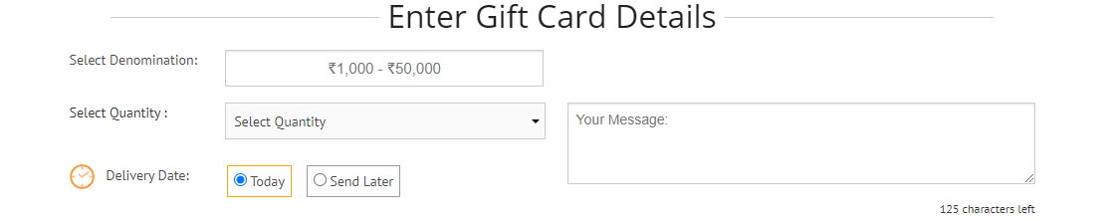

**3.5 Enter Sender and receiver details**

This section has two sides left side will be the sender details and the right side will be the receiver details. After this two sections will be the preview of the Gift card and the terms and conditions for the valid gift card.

* Enter the Sender’s name
* Enter the Sender’s Email address
* Enter the sender’s address in the Address line 1 and Address line 2
* Enter the pin code of the sender’s place to fetch the city and state.
* Enter the sender’s mobile number.
* Enter the Receiver’s name.
* Enter the Receiver’s Email address.
* Re-enter the receiver’s Email address.
* Enter the Receiver’s mobile number.

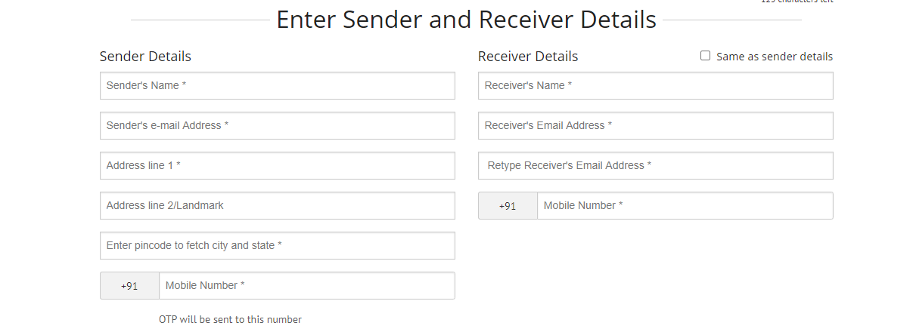

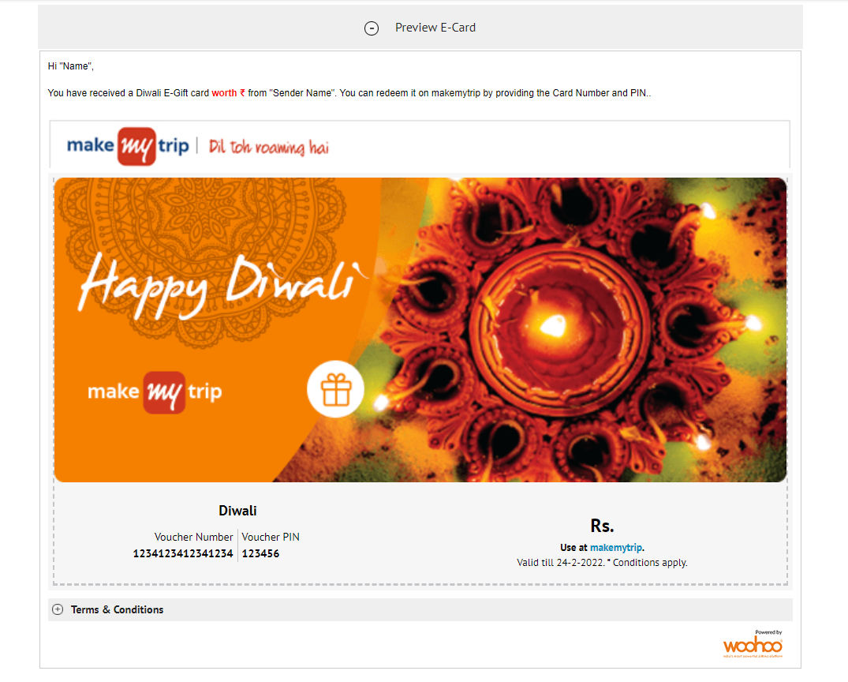

**3.6 Proceed to payment**

This section only has three things, the first one is the Promo code textbox. This will get the user to get a discount on the amount payable for the Gift card buying. And to the left of the Have a Promo Code? Is the Payable amount, the user can check the amount to be paid for the Gift card. The last one is the checkbox to accept to the terms and conditions. Then last is the Pay now button this will navigate the user to payment window.

* Enter the Promo Code (if the user has one)
* Click on the checkbox to accept the terms and conditions
* Click on Pay Now button for payment.

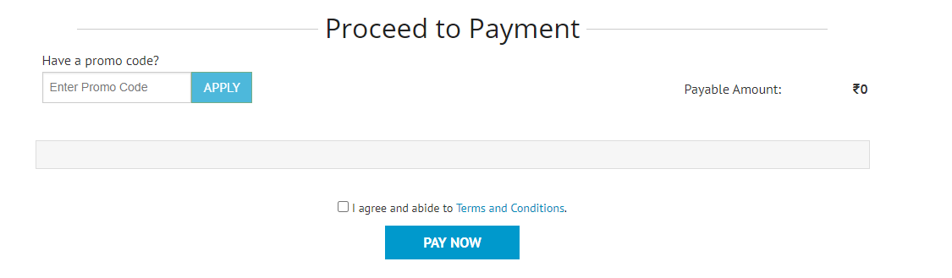

1. **FAQs**

This section is about the website’s most frequently asked questions by the users and answers to the questions so that people can clarify any doubt regarding the purchase of a Gift Card.

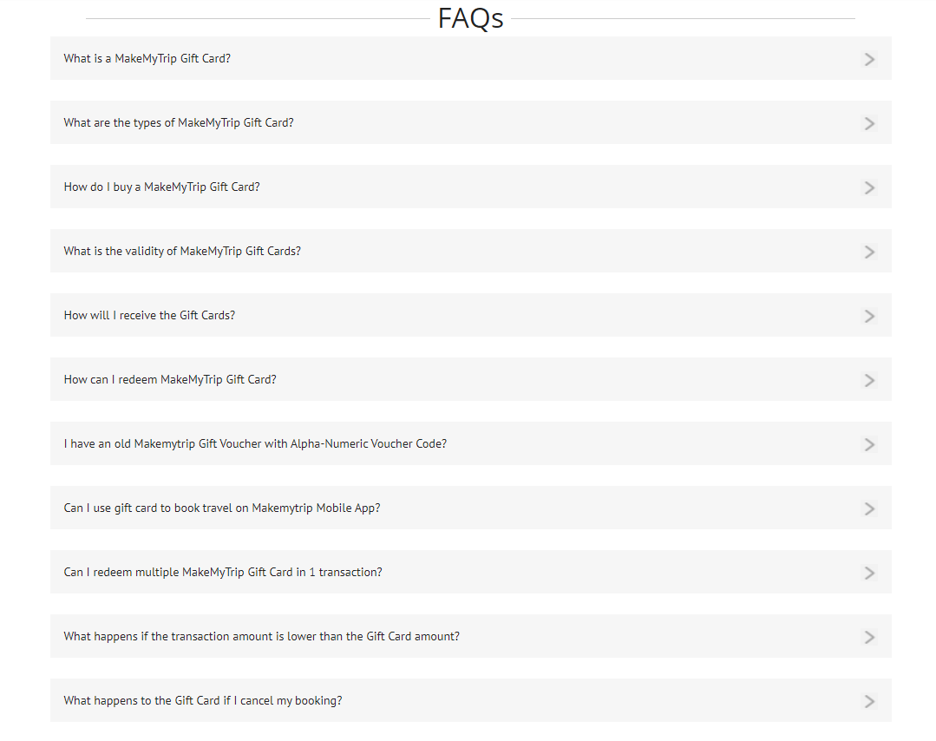

1. **Terms and Conditions**

This section is the terms and conditions to the users about the purchase and the usage of the Gift cards that are purchased in this website by the users.

